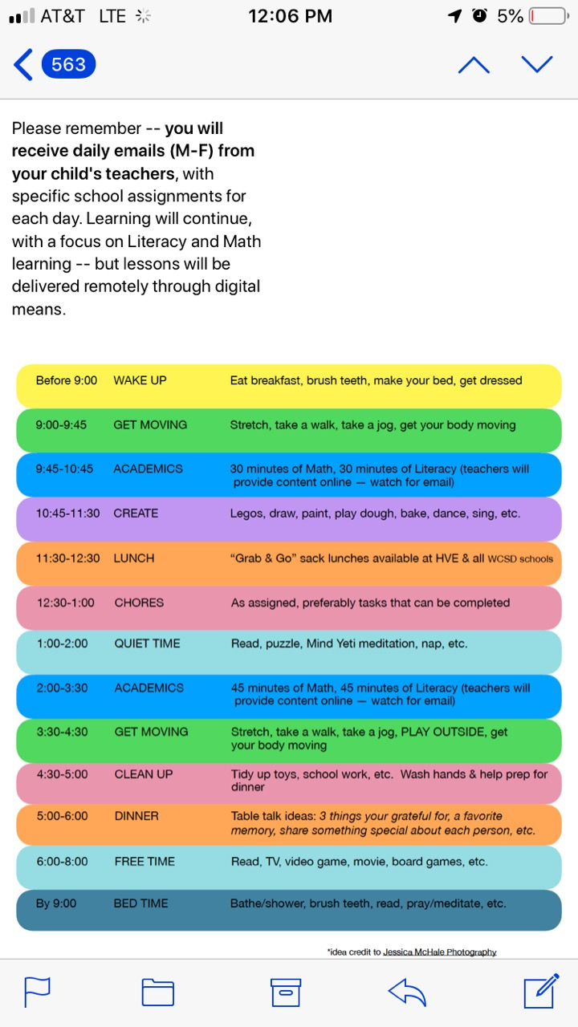

|  |  |
| --- | --- |
|  | C:\Users\chandeep.kohli\Downloads\wake up.pngwake up |
|  | C:\Users\chandeep.kohli\Downloads\eat breakfast.pngeat breakfast |
|  | **C:\Users\chandeep.kohli\Downloads\brush teeth.png**brush eat |
|  | C:\Users\chandeep.kohli\Downloads\make bed.pngmake your bed |
|  | C:\Users\chandeep.kohli\Downloads\dress.png  get dressed |



|  |  |
| --- | --- |
|  | C:\Users\chandeep.kohli\Downloads\stretch.pngstretch |
|  | C:\Users\chandeep.kohli\Downloads\walk.pngtake a walk |
|  | **C:\Users\chandeep.kohli\Downloads\jog.png**jog |
|  | C:\Users\chandeep.kohli\Downloads\wiggle.pngmove your body |



|  |  |
| --- | --- |
|  | C:\Users\chandeep.kohli\Downloads\math tub.pngC:\Users\chandeep.kohli\Downloads\math.png9:45–10:15 math |
|  | 10:15 – 10:45  C:\Users\chandeep.kohli\Downloads\write on dry erase board.pngC:\Users\chandeep.kohli\Downloads\read together.pngreading & writing |



|  |  |
| --- | --- |
|  | C:\Users\chandeep.kohli\Downloads\Legos.pnglegos |
|  | C:\Users\chandeep.kohli\Downloads\draw (1).pngdraw |
|  | **C:\Users\chandeep.kohli\Downloads\paint.png**paint |
|  | **C:\Users\chandeep.kohli\Downloads\Play Doh.png**playdoh |
|  | C:\Users\chandeep.kohli\Downloads\bake cookies.pngbake |
|  | C:\Users\chandeep.kohli\Downloads\dance.pngdance |



|  |  |
| --- | --- |
|  | C:\Users\chandeep.kohli\Downloads\lunch (1).pnglunch |

12:30 – 1:00 Science and Social Studies

|  |  |
| --- | --- |
|  | C:\Users\chandeep.kohli\Downloads\world history (2).pngC:\Users\chandeep.kohli\Downloads\science.pngscience and  social studies |



|  |  |
| --- | --- |
|  | C:\Users\chandeep.kohli\Downloads\nap time.pngC:\Users\chandeep.kohli\Downloads\puzzle.pngC:\Users\chandeep.kohli\Downloads\read.pngquiet time |



|  |  |
| --- | --- |
|  | C:\Users\chandeep.kohli\Downloads\math.pngC:\Users\chandeep.kohli\Downloads\math tub.png2:00 – 2:45 math |
|  | C:\Users\chandeep.kohli\Downloads\read together.pngC:\Users\chandeep.kohli\Downloads\write on dry erase board.png 2:45 – 3:30  reading & writing |



|  |  |
| --- | --- |
|  | C:\Users\chandeep.kohli\Downloads\stretch.pngstretch |
|  | C:\Users\chandeep.kohli\Downloads\walk.pngtake a walk |
|  | **C:\Users\chandeep.kohli\Downloads\jog.png**jog |
|  | C:\Users\chandeep.kohli\Downloads\jungle gym.pngplay outside |



|  |  |
| --- | --- |
|  | **C:\Users\chandeep.kohli\Downloads\put toys away in basket.png**clean up |
|  | C:\Users\chandeep.kohli\Downloads\school work.pngschool work |
|  | C:\Users\chandeep.kohli\Downloads\lather soap.pngwash hands |
|  | C:\Users\chandeep.kohli\Downloads\set table.pngPrep for  dinner |



|  |  |
| --- | --- |
|  | C:\Users\chandeep.kohli\Downloads\lunch (1).pngdinner |



|  |  |
| --- | --- |
|  | C:\Users\chandeep.kohli\Downloads\read (1).pngread |
|  | C:\Users\chandeep.kohli\Downloads\TV viewer.pngwatch TV |
|  | C:\Users\chandeep.kohli\Downloads\video game.pngvideo games |
|  | C:\Users\chandeep.kohli\Downloads\game.pngboard game |



|  |  |
| --- | --- |
|  | C:\Users\chandeep.kohli\Downloads\bubble bath.pngbath |
|  | C:\Users\chandeep.kohli\Downloads\brush teeth.pngbrush teeth |
|  | C:\Users\chandeep.kohli\Downloads\bedtime story.pngbedtime  story |
|  | C:\Users\chandeep.kohli\Downloads\bedtime.pngbedtime |